**Assignment -3**

Cloud Object Storage and Watson Assistant

|  |  |
| --- | --- |
| Assignment Date | 18 Nov 2022 |
| Student Name | J Harish |
| Team ID | PNT2022TMID30065 |
| Maximum Marks | 2 Marks |

**Question-1:**

Create a Bucket in IBM object storage

**Solution:**

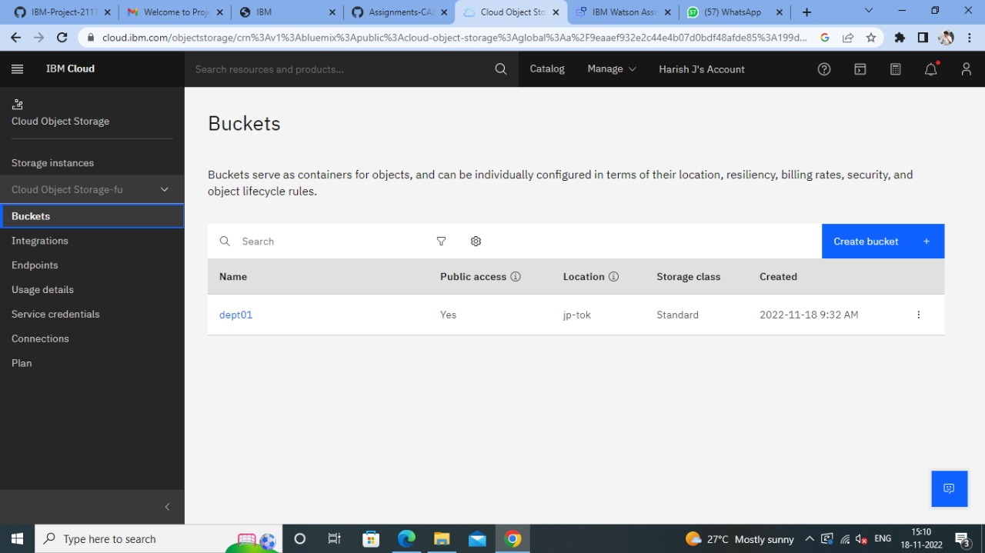

**Question-2:**

Upload an 5 images to ibm object storage and make it public. write html code to displaying all the 5 images.

**Solution:**

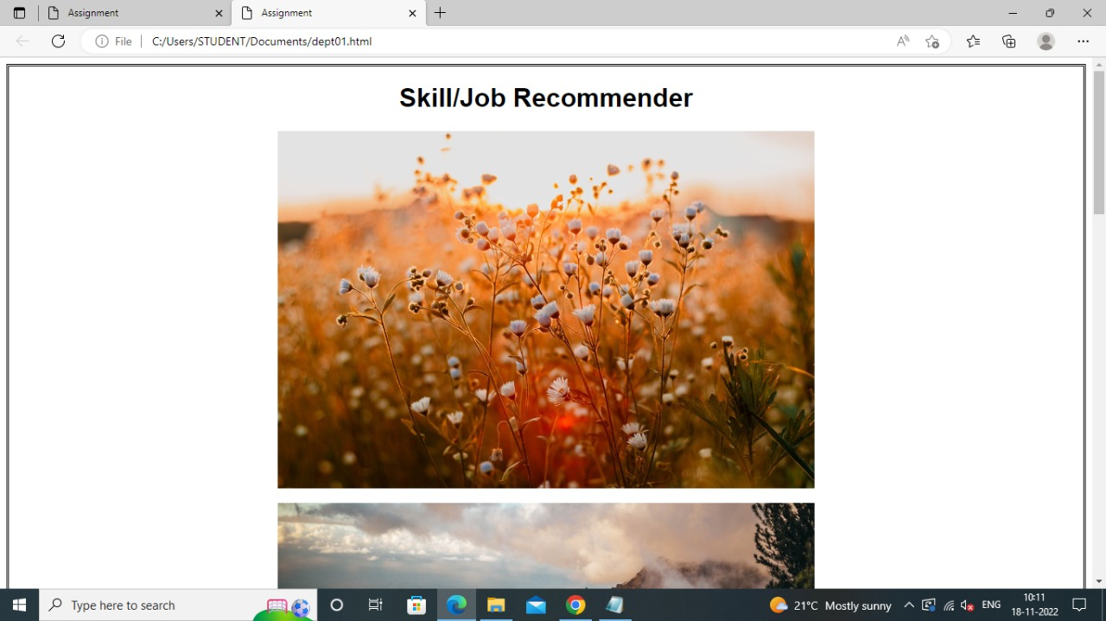

**HTML CODE:**

<!DOCTYPE html>

<title>Assignment</title>

<head>

<style>

img{

display: block;

margin-left: auto;

margin-right: auto;

border: aqua;

width: 50%;

}

Body{

style="border:rgb(15, 15, 15);

border-width:5px;

border-style:double;text-align: center;font-family: Arial, Helvetica, sans-serif;

background-color:green"

}

</style>

</head>

<body style="background-color: sky blue;">

<h1>Skill/Job Recommender</h1>

<img src="https://s3.jp-tok.cloud-object-storage.appdomain.cloud/dept01/Flower.jpeg"

alt="Green" style="width:50%" >

<br>

<img src="https://s3.jp-tok.cloud-object-storage.appdomain.cloud/dept01/Hills.jpeg"

alt="Green" style="width:50%" >

<br>

<img src="https://s3.jp-tok.cloud-object-storage.appdomain.cloud/dept01/Leaf.jpeg"

alt="Green" style="width:50%" >

<br>

<img src="https://s3.jp-tok.cloud-object-storage.appdomain.cloud/dept01/Oceans.jpeg"

alt="Green" style="width:50%" >

<br>

<img src="https://s3.jp-tok.cloud-object-storage.appdomain.cloud/dept01/Sets.jpeg"

alt="Green" style="width:50%" >

</body>

</html>

**Question-3:**

Upload a css page to the object storage and use the same page in your HTML code.

**Solution:**

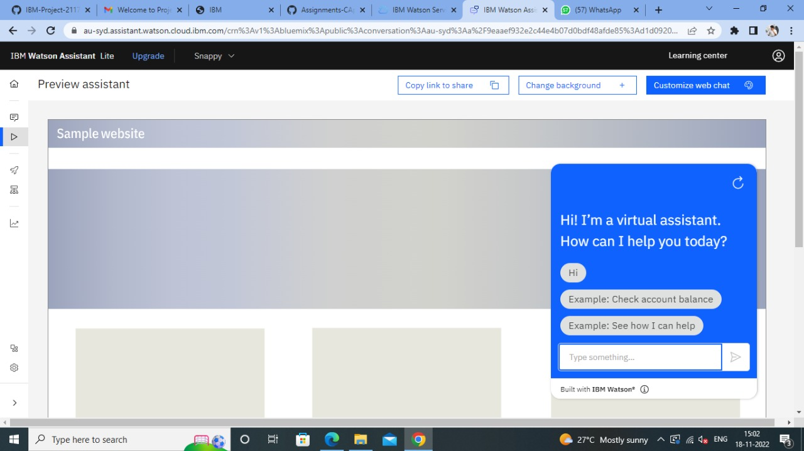

**Question-4:**

Design a chatbot using IBM Watson assistant for hospital. Ex: User comes with query to know the branches for that hospital in your city. Submit the web URL of that chat bot as a assignment.

**Solution:**

**URL:**

<https://web-chat.global.assistant.watson.appdomain.cloud/preview.html?backgroundImageURL=https%3A%2F%2Fau-syd.assistant.watson.cloud.ibm.com%2Fpublic%2Fimages%2Fupx-d1d0920b-375c-45bf-ae9f-0c3f53a67008%3A%3Ace475edd-5676-43ae-bb1f-d725f4bc1c0b&integrationID=f8a09e53-798d-4c54-ab8e-6c5fae57cdf6&region=au-syd&serviceInstanceID=d1d0920b-375c-45bf-ae9f-0c3f53a67008>

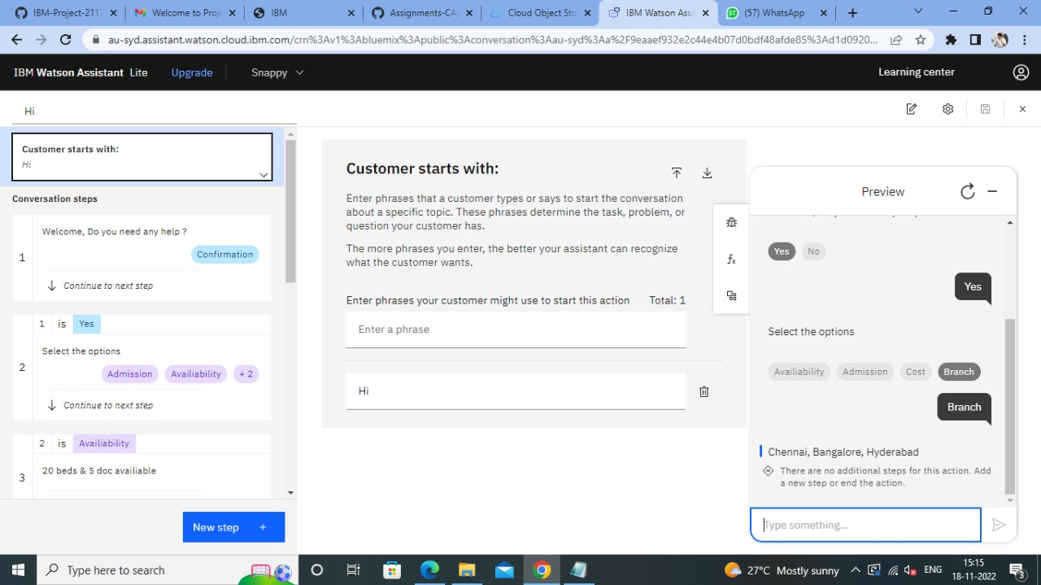

**Question-5:**

Create Watson assistant service with 10 steps and use 3 conditions in it. Load that script in HTML page .

**Solution:**

<style>

body {

font-family: Verdana, Geneva, Tahoma, sans-serif; background-color:rgb(241, 120, 128);

font-size: 1.7rem; color: rgb(1, 22, 74);

}

a {

color: rgb(25, 52, 0); text-decoration: none;

}

h1{

text-shadow: 2px 2px 8px #C01986;

background-image:"C:\Users\G RENUKA DEVI\OneDrive\Desktop\healthcare-technology-doctor-using-digital-tablet-iconmedical-network-hospital-background-162019727.jpg";

background-repeat:no-repeat;

background-size: cover;

}

a:hover {

color: rgb(0, 29, 1); padding: 5px 20px;

background-color: #C8D40C; border-radius: 5px;

transition: .5s ease-in-out;

}

</style>

</head>

<body>

<center><br><br><br>

<h1>Ramachandra Hospital</h1><br>

<a

href="https://web-chat.global.assistant.watson.appdomain.cloud/preview.html?backgroundImageURL=https%3A%2F%2Fau-syd.assistant.watson.cloud.ibm.com%2Fpublic%2Fimages%2Fupx-d1d0920b-375c-45bf-ae9f-0c3f53a67008%3A%3Ace475edd-5676-43ae-bb1f-d725f4bc1c0b&integrationID=f8a09e53-798d-4c54-ab8e-6c5fae57cdf6&region=au-syd&serviceInstanceID=d1d0920b-375c-45bf-ae9f-0c3f53a67008">

Click here for assistance

</a>

<img src="C:\Users\STUDENT\Pictures\hospital.jpeg">

</center>

<script>

window.watsonAssistantChatOptions = {

integrationID: "f8a09e53-798d-4c54-ab8e-6c5fae57cdf6", // The ID of this integration.

region: "au-syd", // The region your integration is hosted in.

serviceInstanceID: "d1d0920b-375c-45bf-ae9f-0c3f53a67008", // The ID of your service instance.

onLoad: function(instance) { instance.render(); }

};

setTimeout(function(){

const t=document.createElement('script');

t.src="https://web-chat.global.assistant.watson.appdomain.cloud/versions/" + (window.watsonAssistantChatOptions.clientVersion || 'latest') + "/WatsonAssistantChatEntry.js";

document.head.appendChild(t);

});

</script>

</body>

OUTPUT:

